Limited vs. Unlimited Governments
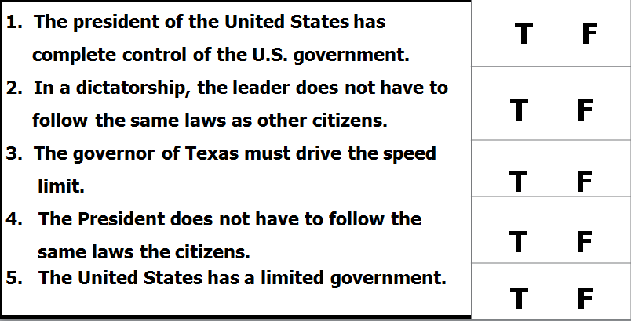
Limited Government Unlimited Government
- _____ Citizens or their elected representatives can remove elected officials from office.
- _____ The media, newspaper, magazines and television can freely report news from around the world.
- _____ The military shuts down newspapers and decides who can run in an election.
- _____ Citizens have few individual rights.
- _____ A national constitution limits the power of government.
- _____ Individuals have basic rights such as freedom of speech, press, assembly, and religion.
- _____ Totalitarian Government
- _____ Democratic-republic government
- _____ People who disagree with the government are arrested.
- _____ Well-educated citizens
- _____ Low literacy rate
- _____ Citizens must have permission from the government to leave the country

