THE ISLAND CHALLENGE

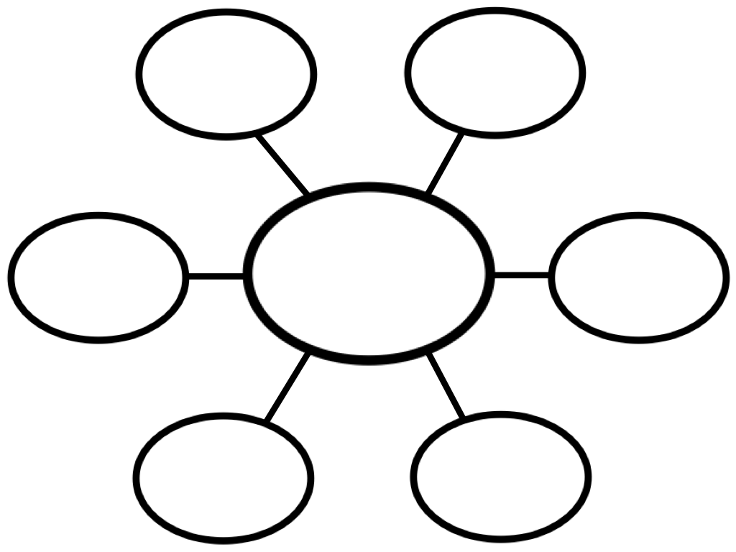

GOVERNMENT:
- _____________________________ and changes ___________________________
- Decides how much people should pay in _____________________________ and how that money should be spent.
- Can control access to ___________________________ and _________________________ care.
- Decides if people have the ______________________to __________________________those in power

__________________________- Government where _________ _____________________ has total power

__________________________- Government where the ______________________ have the power.

